**SPH3U: 4.2 Friction**

1. **Static vs. kinetic friction**

|  |  |
| --- | --- |
| Static friction: |  |
| Kinetic friction: |  |

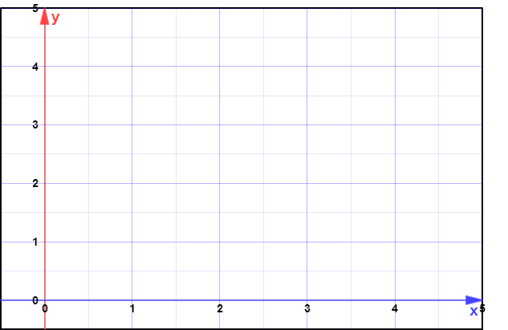Friction vs. the applied force:

1. **Coefficients of friction**

|  |  |
| --- | --- |
| Frictional force depends on: |  |
| coefficients of friction |  |

Some approximate coefficients of kinetic and static friction:

|  |  |  |
| --- | --- | --- |
| **Material** | **μS** | **μK** |
| rubber on asphalt (dry) |  | 0.5–0.80 |
| rubber on asphalt (wet) |  | 0.25–0.75 |
| steel on steel (dry) | 0.78 | 0.42 |
| steel on steel (greasy) | 0.05–0.11 | 0.029–0.12 |
| ice on ice | 0.1 | 0.03 |
| steel on ice | 0.1 | 0.01 |
| Teflon on Teflon | 0.04 | 0.04 |
| near-frictionless carbon |  | 0.001 |
| synovial joints in humans | 0.01 | 0.003 |

1. **Determining the forces of friction**

A 3.0 kg block of wood sits on a horizontal wooden floor. The largest horizontal force that can be applied to the block before it will start moving is 14.7 N. Once the block starts moving, it only takes 8.8 N to keep it moving at a constant velocity.

1. Calculate the coefficient of static friction for the block and the floor.
2. Determine the force of friction acting on the block if a horizontal force of 6.8 N [E] acts on the block.
3. Calculate the maximum magnitude of static friction acting on the block if a 2.1 kg object is placed on top of it.
4. Determine the coefficient of kinetic friction.

**Homework:** page 172: #1-2, 4-5, 9, 11